MINI WORKSHOP — 3 AI TOOLS YOU MUST KNOW ABOUT
  - + bonus hack

Podcast/mindmap/video from your sources → NotebookLM
Notebook LM is an AI tool from Google that lets you upload your own notes, readings, or documents and then interact with them through summaries, audio overviews, Q&As, etc. Instead of searching the whole internet, it focuses only on your materials, helping you organize, review, and understand information faster.
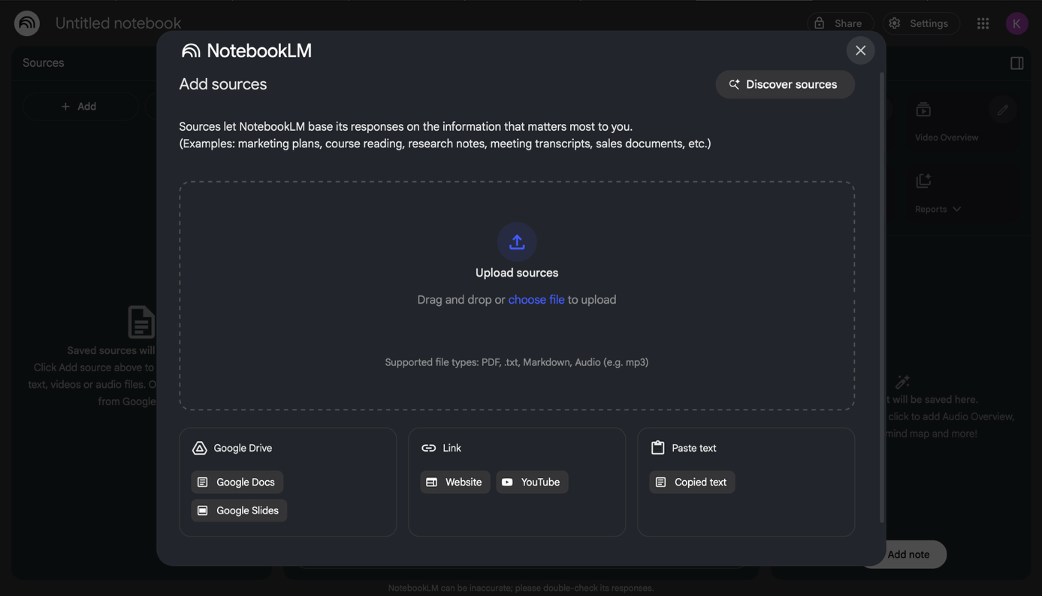

Upload your sources
Upload PDFs, websites, YouTube videos, audio files, Google Docs, or Google Slides, text and NotebookLM will summarize them and make interesting connections between topics.

Pro Tip: if a website blocks NotebookLM from adding them as a source, copy and paste text from this website instead


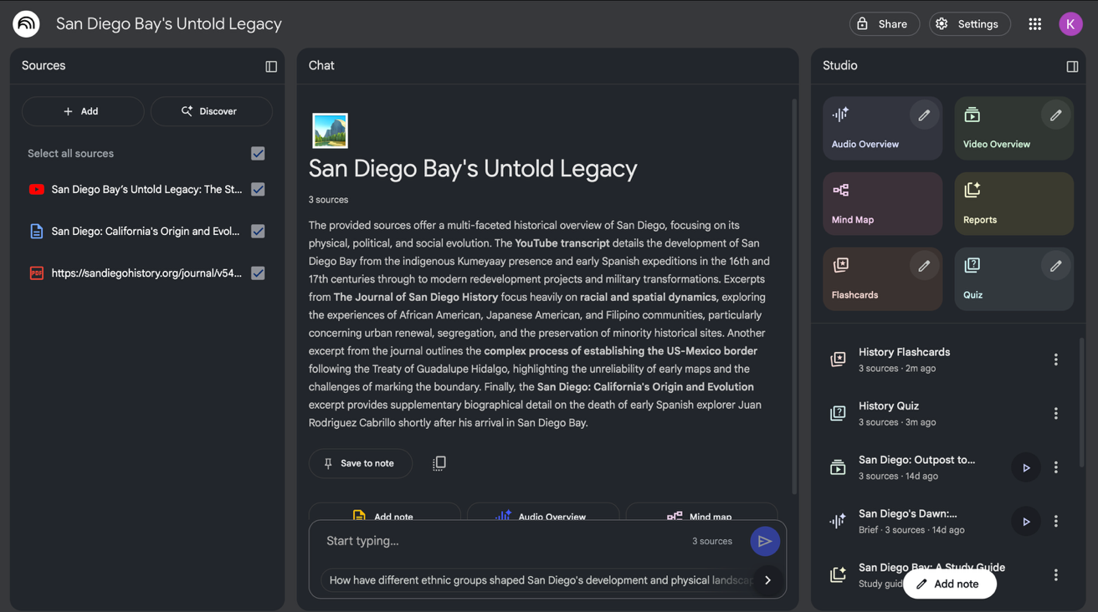
Get comprehensive summary and key topics overview of individual sources

With all your sources in place, NotebookLM gets to work and becomes a personalized AI expert in the information that matters most to you. Create podcasts, educational videos, study guides, and more.
Pro Tip: select or deselect sources to adjust NotebookLM’s searching scope using the checkbox near each source

ASK for guidance→Google ai studio (stream feature)
Google AI Studio’s Stream feature lets users interact with AI models in real time, receiving responses word-by-word as they’re generated. This makes it easier to test prompts and see how the model thinks step by step. For studying, it can be used to practice Q&A sessions or create interactive study aids. It also includes a share screen option, which allows the model to guide you through tasks as you work on them live on your computer.
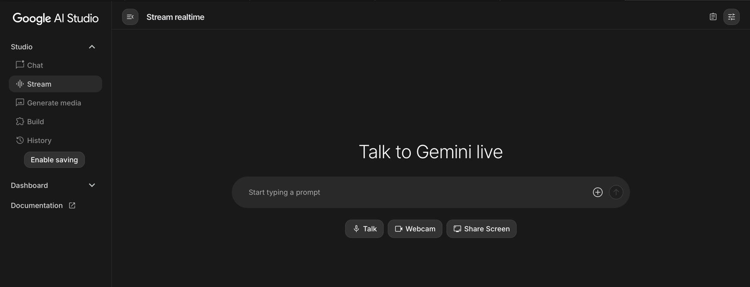

Select Talk and have a real time conversation with Google Gemini model.
If you click Share Screen and enable screen sharing, you may speak or type to Gemini. The AI will see what’s on your screen and can provide step-by-step help, answer questions, or guide through tasks in real time.
It’s worth noting that the share screen technology is still being refined and may occasionally encounter bugs.

Turn lectures into notes→Mem ai (voice mode)
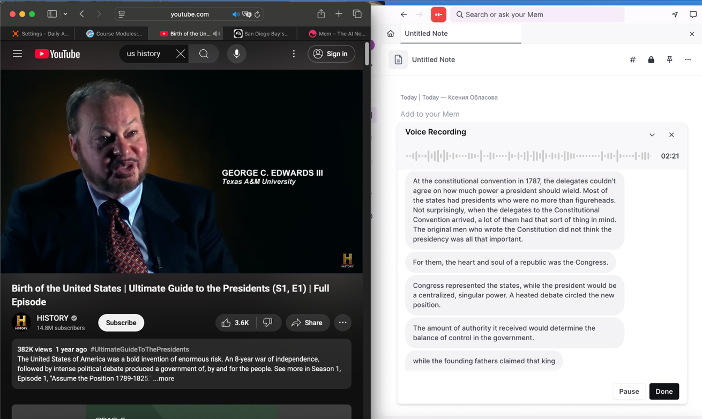
Mem AI’s Voice Mode lets you capture spoken content—like lectures, meetings, or videos—and automatically turn it into structured notes, and have the AI generate clear summaries, highlights, and action points.

Start voice recording in Mem AI while watching a lecture, having an online class, or speaking yourself. Once you stop, Mem AI will generate structured notes based on the material provided.
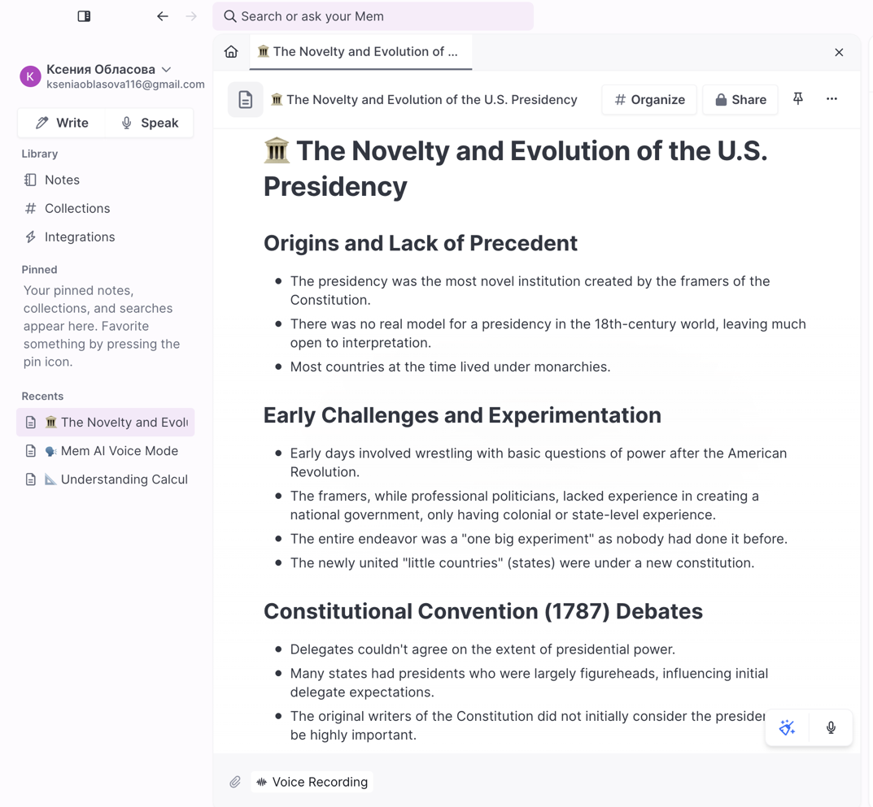

Bonus: turn perplexity ai into reliable search engine
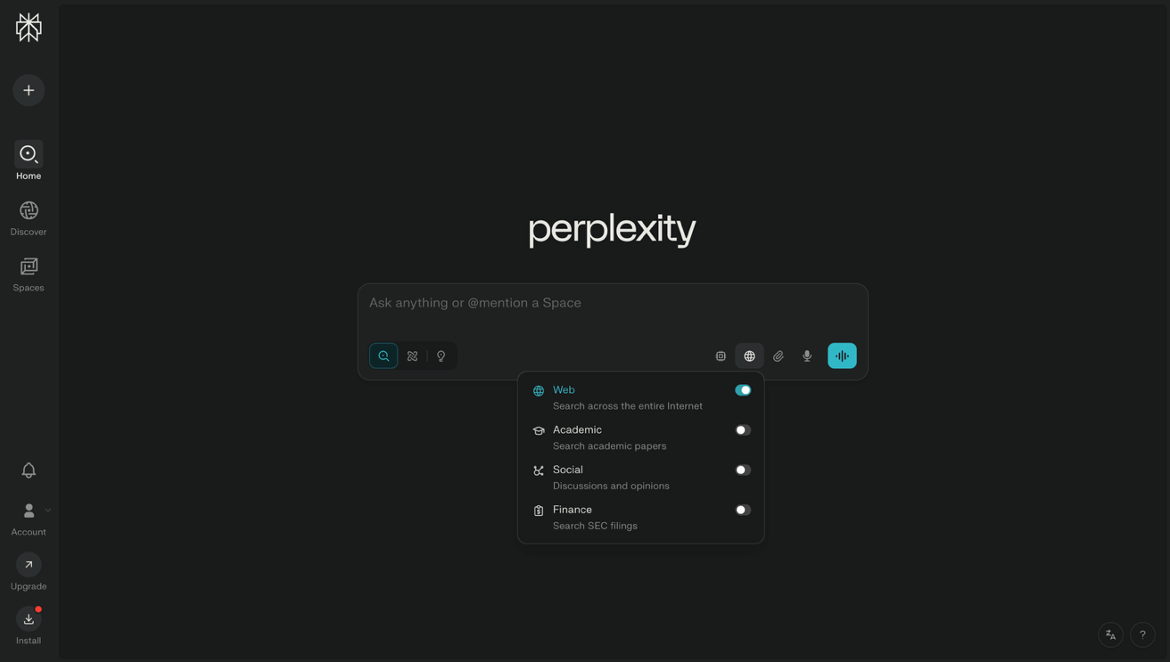
Perplexity AI is an AI-powered search engine that answers questions with concise, well-sourced responses. It combines conversational AI with real-time web search, showing citations so you can verify information. It’s useful for quick research, fact-checking, and exploring topics with reliable references.

Perplexity AI lets you refine results by using the “choose sources” button, which limits the AI to search only within selected websites or databases. This makes answers more reliable and tailored to your needs, since you control where the information comes from.

